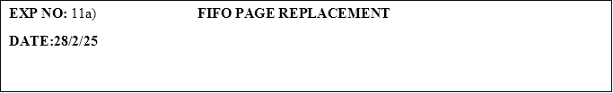

**PROGRAM:**

#include <stdio.h>

#define MAX 10

void fifoPageReplacement(int pages[], int n, int capacity) {

int frame[capacity];

int pageFaults = 0, front = 0, rear = 0, flag;

for (int i = 0; i < capacity; i++) {

frame[i] = -1;

}

printf("Page Reference String: ");

for (int i = 0; i < n; i++) {

printf("%d ", pages[i]);

}

printf("\n");

for (int i = 0; i < n; i++) {

flag = 0;

for (int j = 0; j < capacity; j++) {

if (frame[j] == pages[i]) {

flag = 1;

break;

}

}

if (flag == 0) {

frame[rear] = pages[i];

rear = (rear + 1) % capacity;

pageFaults++;

printf("Page Fault: ");

for (int j = 0; j < capacity; j++) {

if (frame[j] != -1) {

printf("%d ", frame[j]);

}

}

printf("\n");

}

}

printf("\nTotal Page Faults: %d\n", pageFaults);

}

int main() {

int pages[MAX], n, capacity;

printf("Enter the number of pages: ");

scanf("%d", &n);

printf("Enter the page reference string:\n");

for (int i = 0; i < n; i++) {

scanf("%d", &pages[i]);

}

printf("Enter the number of frames (capacity of memory): ");

scanf("%d", &capacity);

fifoPageReplacement(pages, n, capacity);

return 0;

}

**OUTPUT:**

Enter the number of pages: 2

Enter the page reference string:

3

2

Enter the number of frames (capacity of memory): 4

Page Reference String: 3 2

Page Fault: 3

Page Fault: 3 2

Total Page Faults: 2